Ridgecrest Elementary
Attendance Policy

Attendance Goal: All students will attend school at least 95% of the school year. To achieve this goal, students cannot miss more than 8 days of school for the year.

School attendance is very important. Every absence from school interferes with your child's opportunity to learn. There is a growing body of research showing that Chronic Absenteeism, usually defined by researchers as missing 10% or more of the school year (including excused and unexcused absences), has a significant negative effect on student achievement and may put a student at academic risk. The goal for Ridgecrest Elementary is that all students miss no more than 5% of the school year, to help every student be successful now and in the future.

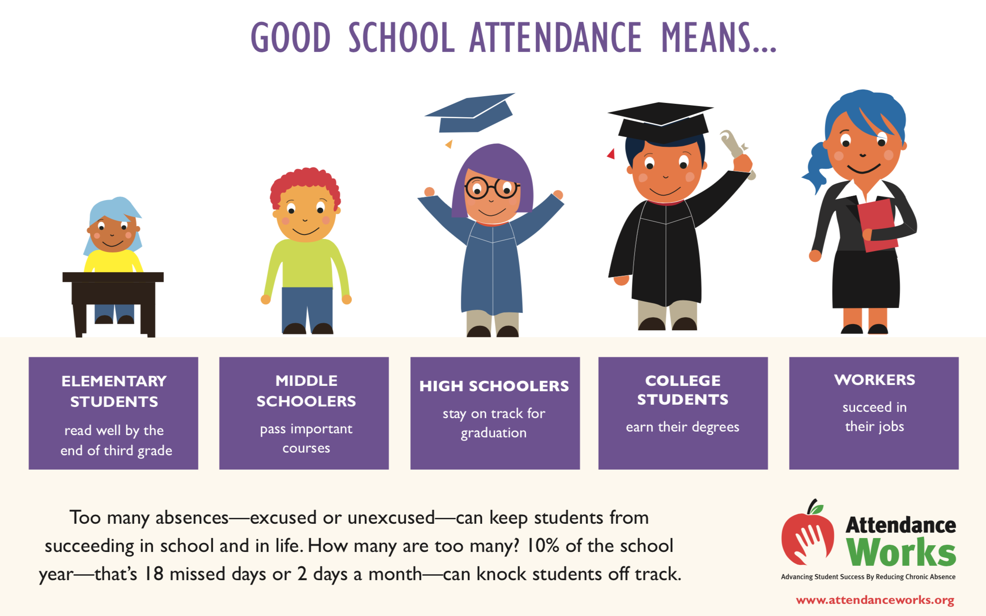

School Success Goes Hand in Hand with Being in School Every Day! Did You Know?
- Many absences, even in kindergarten, can cause children to fall behind in school.
- Missing just a day or two every month can make it harder to learn to read by the third grade.
- Students with too many absences struggle to catch up, even with take-home assignments.
- Attending school regularly helps children feel better about school and themselves.

What Can You Do?
- Develop a regular bedtime and morning routine.
- Avoid missing school unless a child is truly sick and seek help if chronic illness is a challenge. Check with our school nurse or office staff if you are not sure about when to keep your child at home due to illness.
- If your child seems anxious about going to school, talk to teachers, school support staff, or other parents for advice on how to make him/her feel comfortable and excited about learning.

Types of Absences: Canyons District policy 500.35
- Valid Excused Absence:
- An illness, which may be either mental or physical, regardless of whether the school-age child or parent provides documentation from a medical professional;
- Mental or behavior health of the school-age child;
- A family death;
- An approved school activity;
- An absence permitted by a school age minor’s individualized education program (IEP) or Section 504 accommodation plan; or
- Any other valid excuse approved by the local school board. The Canyons Board of Education has approved the following as additional valid excuses:
  - A family emergency; A family event; Observance of religious holiday; Medical appointment; Scheduled pre-approved education leave
- The District or school may not require documentation from a medical professional to substantiate a valid excuse that is a mental or physical illness.

- Guardian Excused Absence: An absence excused by a parent/legal guardian within up to five (5) school days of the absence occurring.
- Unexcused Absence: Any absence without a valid excuse.

Communication Procedure for Valid Excused Absences:
- All absences are considered unexcused until the parent communicates with the school regarding the student’s absence, and the absence is resolved by the school staff.

- Procedure for Education/Vacation Leave: A student may be allowed up to ten (10) days for education/vacation leave in a given school year if prior arrangements have been made with the school for the student to make up his/her homework. Prior to education leave, parents complete an Education Leave Form for approval. Teachers will complete the “Work to Be Completed” section and determine a reasonable due date. School administration will verify education leave.

Standard Notification Schedule:
Policy Approved by the Ridgecrest SCC 10/10/19 and Building Leadership Team on 10/9/19
Unexcused Days Absent | Notification
3-5 | Phone Call or Email from the teacher and/or the attendance secretary. They will inquire if the student is doing okay, express concern, and ask what the school can do to support the student making up work and not falling behind.
6-8 | Inquiry Letter #1 - The attendance secretary will call parent explaining that the student has missed 6-8 days of school and reminding the parent of the importance of regular school attendance. Date of communication will be documented. Staff will send Inquiry Letter 1 through regular mail and document date of communication in Skyward. Student is considered for attendance interventions.
9-11 | Inquiry Letter 2 - Second inquiry letter, encouraging conference with school administrator. Administrator will identify a date, time, and location to meet with parents. Office Staff will send Inquiry Letter 2 through regular mail and document the date sent. If parents do not attend the scheduled meeting, Admin will call and office staff will document. Place student in attendance intervention or review attendance intervention already in place. Collect and review attendance intervention and attendance data (4 week period).
12 | Letter 3 Sent Certified Mail- Schedule district conference with Responsive Services Department administrator, school administrator, family, and student at the school. Office Staff will send Letter 3 certified mail and document the date sent. Collect and review attendance intervention and attendance data (3 week period).

