Ridgecrest Elementary School Community Council
Monthly Meeting Agenda
Wednesday, February 22, 2023- 4:00pm- Virtual Zoom

Sara Allen, Principal; Annette Hubley, teacher; Londyn Freeman, teacher; Summer Gallegos, parent; Stephanie Pierson, parent; Anna Whiteley, parent & Vice-Chair; Carrie Christensen, parent; Julia Jensen, parent & secretary; Brad Hunter, parent.

Call to Order @ 4:12

- Remaining Accadiance Data presented:

Overview of Three-Tiered support system for student academic and behavior success - Tier One: 80% of students receive the support they need to achieve benchmarks. Tier Two: 10-15% of students need additional support to be successful. Tier three: 5-10% students receive 1:1, intense, on-going support. This tiered system best describes the school-wide system and not individual students or classrooms.

School Report Card - RISE Comparison data: This data is for 3-5th graders only. Focus is on growth of lowest 25%. You need a base year (3rd grade) to measure growth in 4th and 5th grades. This goes into state report cards and is counted twice. We see a culmination of what students can do. Our data shows average scores. Language arts is lowest, with math and science testing higher. This is typical for most schools in our state. The data shows average growth. (compared to the median student in the district and state).

Q: Does this reflect data differences between the immersion classrooms and gen ed classrooms? A: The data does not show that immersion students do worse.

The data shows the English Language Learners (or MLs) did not grow as much as we would have liked. We have given them added focus this school year. We have a wide array of proficiency at Ridgecrest and want to focus on growth as well as proficiency.

Summarized Comparison Data: Our growth was lowest in Language Arts and Math showed about average.

Math Acadience Composite: Test scores over the past few years have been influenced by Covid. There is growth from the starting percentage in fall and through the year. The MLs (ELLs) show growth from last school year. These numbers also reflect the increase of more MLs moving into the school. As the year progresses the benchmark also moves and some students who meet the benchmark in Fall do not always meet the benchmark in Winter and we see this in the data.

(Building Leadership Team) BLT 2023-24 Math goal: 70% of K-5 proficient by Spring 2024; at least 75% of K-5 students meet or exceed typical growth. We changed from focusing on just growth and included proficiency to capture the achievements of our students consistently meeting and exceeding benchmarks.

Q: How are the percentages between growth and proficiency different? The principal discussed the reason for choosing 70% as the benchmark for next year. A teacher clarified the difference between measuring growth versus proficiency.

Reading Composite: A beginning percentage of 66% proficiency in grades 1-3; the benchmark moved and that percentage dropped a bit. ML’s scores dropped at winter testing. We’re working to turn this around. Grades 4-5 benchmark (RI test) does not change and they are making a lot of growth from fall to winter. Grades 1-3 are seeing growth, however the beginning percentage was lower this year than previous years. BLT has discussed this data. It is believed that the new curriculum has affected this percentage. All subgroups saw a downward trend from year to year. We are currently problem-solving this in the BLT. Grades 4-5 on RI: 52% of students making typical growth. Goal was 75% so we have a lot of room to improve. Grades 3-4 were most affected by Covid. We’ve also seen a big influx of MLs in 4th grade. Learning how to take the RI test is also a factor.

BLT 2023-24 Reading Goal: The progress of reading is not linear but exponential. These goals break down the composite scores to capture the growth and proficiency of all students.
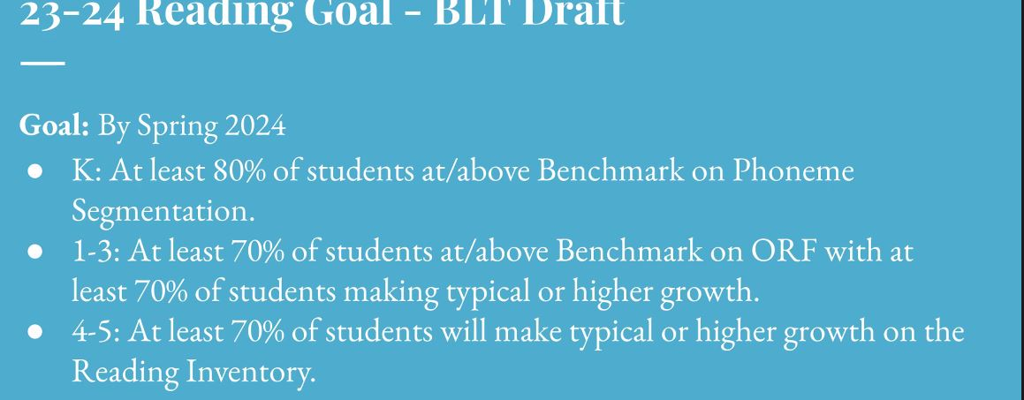
Q: Who makes up the BLT? Team leads of each grade (a teacher from each grade) and the team lead for the immersion teachers, achievement coach, school counselor, and principal.

The goals from BLT are in response to filling the gaps created by Covid, especially among 3-5 graders. The objective was to set goals that all students could meet and feel successful, as well as help them to grow to where they need to be eventually (80%) in steps. Teachers want to feel some success as well. Several SCC members shared their appreciation for setting goals that understand the impact COVID had on certain grades and will meet them where they’re at while also starting to look for proficiency long term.

PBIS: Last year’s goal was to reduce office discipline referrals (ODRs), 4:1 corrective feedback in classrooms in order to affect classroom climate (according to behavior research), foster a sense of community, use SRSSIE to identify students who need additional support.

We are not on track with this goal. October and November had really high referral rates. They have decreased greatly since December. A couple of kids contribute the most to the data. As the students improve we will see these numbers drop significantly.

2:1 positive feedback is a benchmark goal, although our school goal is 4:1.

Attendance data: Students who miss less than 3 days per quarter are considered “on track” for learning. BLT goal: To increase attendance by 5% from term 1, 2, 3 as measured by EWS data.
Idea offered to showcase in the Roar classrooms that finish their Mr. Potato Head.

There was a comment and brief discussion on low attendance rates and potential reasons, including mental health and lack of parental incentives. Our goals can only focus on what we can control and influence the most.

- Begin writing TSSP and LAND Trust plans for next school year

BLT met on 2/10 and 2/22 to work on TSSP & Land trust plans. As a reminder, TSSP stands for Teacher & Student Success Plans. It encompasses school goals and how we use our budgets to achieve those goals and shape what the following school year will look like. The BLT & Principal draft the plans, with input from the SCC, and finalize by March 29th. They are then sent to the district level for approval in early April. TSSP draft was not completed at the most recent BLT meeting due to time.

- Positive Behavior Plan Update and Data
A few goals for this year are:
- Make consequences make sense and more natural.
- Fix the original conflict, do not give consequences only.
After-school academic programs did not happen this year. Commitments will need to be made this year for next year’s after-school programs before we commit money to them.

FYI- March 1: Board of Education receives a report on prior year school plan implementation.

Next meeting on March 29th at 4pm in the library.

Motion to adjourn at 5:40, motion seconded.

